IFT 360

Lab 1

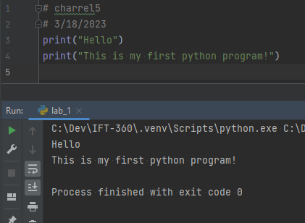

print("Hello")

print("This is my first python program!")

